2018-2019 Education Year.........................Primary School The Second Term The Second Written Exam For The Fourth Graders

Choose the Correct answer 25 X 4=100 points

Name: Surname: Number: Class: Date:

1-Yanda verilen görsele göre aşağıda verilenlerden hangisini **söyleyebiliriz**?

1. Cem is old, Ali is tall.
2. They are plump.
3. Cem is short, Ali is young.
4. Cem is tall, Ali is short



Cem

Ali

2- Tim: What does Ali Sait look like?

1. He can play football.
2. He is young.
3. He likes reading books.
4. He is ten years old.

3- Verilen görsele göre aşağıdakilerden hangisini **söyleyebiliriz**?

1. She has got blonde hair.
2. She has got straight hair.
3. She has got curly hair.
4. She has got wavy hair.

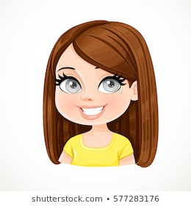

4-Verilen görsel size hangi mevsimi hatırlatmaktadır?

1. Spring c) Winter
2. Summer d) Autumn

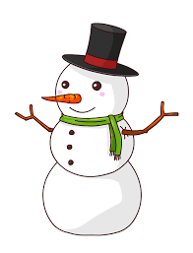

5- Aşağıda verilen resimlerin adlarının doğru sıralandığı seçenek hangisidi?

1. Rainy – Snowy – Sunny
2. Snowy – Sunny – Stormy
3. Sunny – Snowy – Rainy
4. Rainy – Snowy - Cloudy





6- Can:…………………………………..?

Mertcan: It is cold.

Karşılıklı konuşmayı en iyi şekilde tamamlayacak ifadeyi bulun?

1. What can you do?
2. What do you like?
3. Do you like cold?
4. How is the weather?

Ahmet Haşim GARBETOĞLU [www.okuling.com](http://www.okuling.com) İngilizce Eğitim Materyalleri [www.ahingilizce.com](http://www.ahingilizce.com) İngilizce Eğitim Sitesi

7- Aşağıda verilen eşleştirmelerden hangisi **yanlıştır**?

1. c)
2. d)

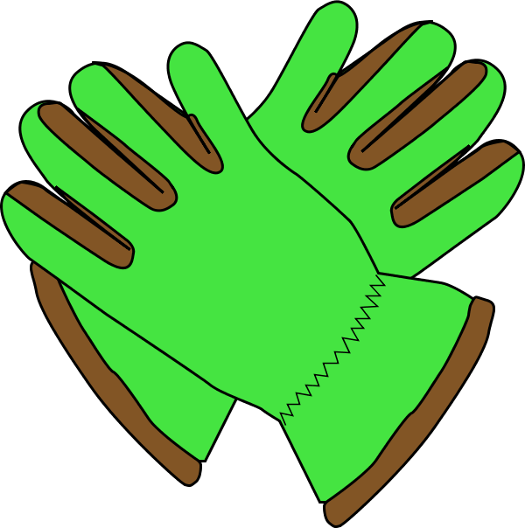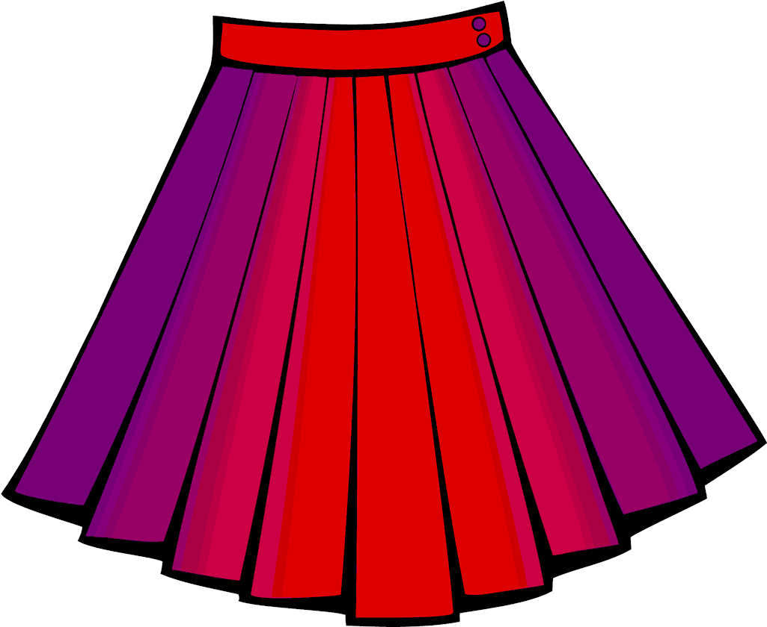

Skirt

Gloves

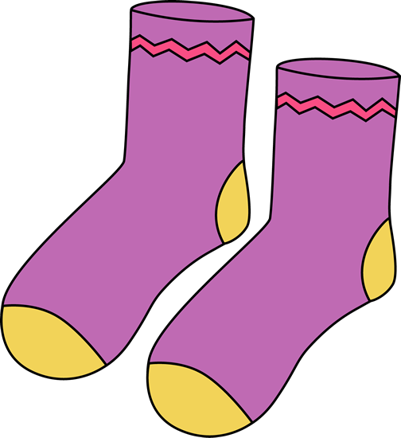

Hat

Jeans

8- Aşağıda verilen aylardan hangi ikisi sıralamayı bozmuştur?

January – February – March – April – May – July – June – August – September – October – November - December

1. March – April c) July – June
2. August – September d) October - November

9- A:…………………………..?

B: I’m a vet.

1. What is your job?
2. What can you do?
3. What do you like?
4. Where are you from?

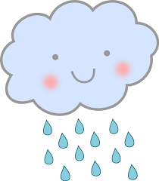

10- Aşağıda verilen durumu en iyi şekilde tamamlayan ifadeyi bulun.

I am a chef,……………………..

1. I like helping people.
2. I like flying.
3. I like writing books.
4. I like cooking.

11- She is a …………

1. waiter c) nurse
2. writer d) farmer



12- A:……………………………

B: It is one o’clock.

Karşılıklı konuşmayı en iyi şekilde tamamlayacak ifadeyi bulun?

1. What time is it?
2. What do you do in the morning?
3. What does your father do?
4. What time do you g oto bed?

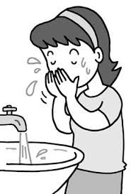

13-

1. I wash my face in the morning.
2. I brush my teeth in the morning.
3. I go to school in the morning.
4. I go to bed in the morning.

14-

1. c)

1. d)

I like riding a bike

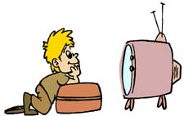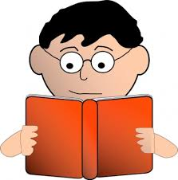



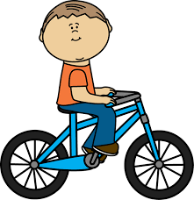

1. Can a parrot fly?

Can a dolphin swim?

Can an elephant dance?

Yukarıda verilen 3 sorunun doğru cevabı sırasıyla hangi seçenekte verilmiştir?

1. Yes, it can - Yes, it can - Yes, it can
2. No, it can’t, Yes, it can - Yes, it can
3. Yes, it can - Yes, it can – No, it can’t
4. Yes, it can – No, it can’t - Yes, it can

10 - 20 – 30 - ……… 50

16-

1. Seventy c) Fifty
2. Forty d)Sixty

Ahmet Haşim GARBETOĞLU [www.okuling.com](http://www.okuling.com) İngilizce Eğitim Materyalleri [www.ahingilizce.com](http://www.ahingilizce.com) İngilizce Eğitim Sitesi

1. Ali can read a book

Cem can swim

Samet can’t drive a car.

Melih can ride a bike.

Yukarıda verilen cümlelerden hangisine ait görsel aşığıda yoktur?

1. c)
2. d)

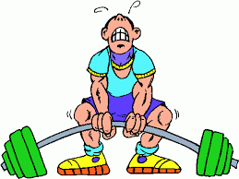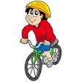





18- Aşağıda verilenlerden hangisinin İngilizcesi yanlış yazılmıştır?

1. c)

Ruler Pencil sharpener

1. d)

Book Table

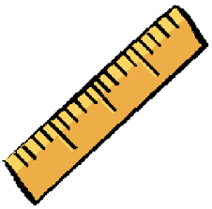

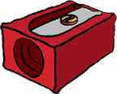

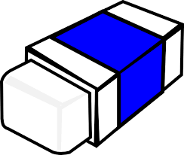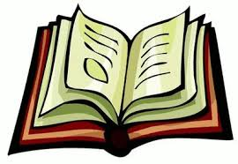

19- A:……………………………

B: I’m French.

Karşılıklı konuşmayı en iyi şekilde tamamlayacak ifadeyi bulun?

1. Where are you from?
2. What is your name?
3. What time is it?
4. What is your nationality?

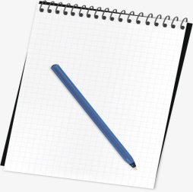

20- The pen is…………….. the notebook.

1. Under b) in c) on d) in front of