2018-2019 Education Year......................Secondary School The Second Term The Second Written Exam For The Sixth Graders

Choose the Correct answer 25 X 4=100 points

Name: Surname: Number: Class: Date:

1-Mehmet: What should we do to reduce air pollution?

Can:Mehmet:………………………………

Karşılıklı konuşmada boş bırakılan yere gelebilecek en uygun ifade aşağıda verilenlerden hangisidir?

1. We should use private cars.
2. We should drive to work.
3. We should cut down trees.
4. We should use public transportation.

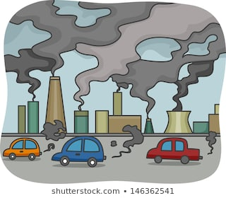

2- Verilen görsel için aşağıdakilerden hanisini söyleyebiliriz?

1. Waste energy c) Water pollution
2. Air pollution d) Recycle batteries

3- Ali : ………………………………………..?

Muhammet:We shouldn’t throw rubbish around.

Karşılıklı konuşmada boş bırakılan yere gelebilecek en uygun ifade aşağıda verilenlerden hangisidir?

1. What should we do to protect the environment
2. Where were you yesterday
3. What did you do in Trabzon
4. What should I do to pass the exam

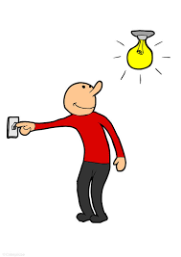

4-

1. He is unplugging the TV.
2. He is wasting water.
3. He is turning on the lights.
4. He is cutting down trees.

5- What are they doing?

1. They are reading a novel.
2. They are reading an e-book.
3. They are reading a newspaper
4. They are reading a storybook.

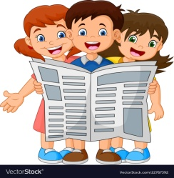

Ahmet Haşim GARBETOĞLU [www.okuling.com](http://www.okuling.com) İngilizce Eğitim Materyalleri [www.ahingilizce.com](http://www.ahingilizce.com) İngilizce Eğitim Sitesi

6-

Çevre konu bir pankart hazırlamak isteyen biri yukarıda verilenlerden hangisini bu pankart’a **yazmamalıdır?**

1. Keep the sea clean
2. Use environmentally friendly products
3. Use Filters
4. Harm animals

Harm animals

Keep the see clean

Use environmentally friendly products

Use filters

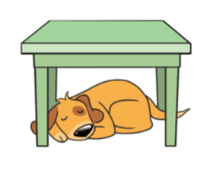

7- The dog is sleeping……………. the table.

1. on c) behind
2. under d) over

8- Zehra:……………………………………….?

Meryem:I read important books.

Karşılıklı konuşmada boş bırakılan yere gelebilecek en uygun ifade aşağıda verilenlerden hangisidir?

1. What did you do in the library yesterday
2. When were you born
3. What time did you get up yesterday
4. Did you buy magazines yesterday

9- Ela visited her grandparents…………….. week.

1. ago c) last
2. yesterday d) tomorrow

10- Verilen görselleri en iyi anlatan ifadeyi bulun.

1. They watched TV
2. They didn’t stay in a tent.
3. They stayed in a tent, they didn’t watch TV.
4. They stayed in a tent and watched TV.

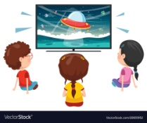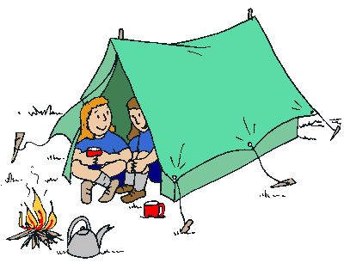

11- Ahmet: Where were you on your holiday?

Hamza: I was at the seaside.

Karşılıklı konuşmada bahsi geçen yer aşağıdakilerden hangisidir?

1. c)
2. d)

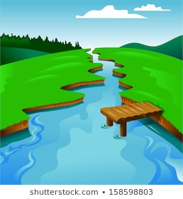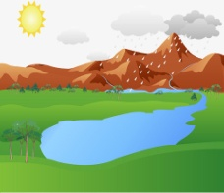

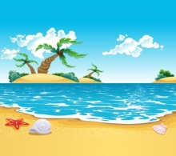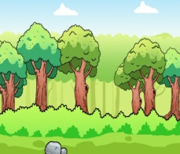

12- I can cut and sew fabric. I am a /an………………

1. tailor c) engineer
2. hairdresser d) waitress

13- The weather…….. sunny yesterday but it……… rainy today.

1. was / is c) is / is
2. was / was d) is / was

14- Verilen tarihin doğru yazıldığı seçeneği işaretleyin.

1. Twenty three, August, nineteen eight four
2. Twenty third of August, nineteen eighty four.
3. Twenty third of August, nineteen eighteen.
4. Twenty three August one thousand eighty four.

**23.08.1984**

15- Hamza:……………………….?

Asaf: He can grow fruits and vegetabes.

Karşılıklı konuşmada boş bırakılan yere gelebilecek en uygun ifade aşağıda verilenlerden hangisidir?

1. What can you do
2. What did Cem do yesterday
3. What can a farmer do
4. Did you buy fruits yesterday

Ahmet: What do you think about ghost trains?

Medine:I hate it. It is………………..

16- Boşluğa uygun düşen ifadeyi bulun.

1. exciting c) boring
2. great d)fantastic

Ahmet Haşim GARBETOĞLU [www.okuling.com](http://www.okuling.com) İngilizce Eğitim Materyalleri [www.ahingilizce.com](http://www.ahingilizce.com) İngilizce Eğitim Sitesi

17- Aşağıda verilen görselleri en iyi ifade eden seçeneği işaretleyin.

1. I feel sad on foggy days.
2. I feel scared on stormy days.
3. I feel anxious on cloudy days.
4. I feel happy on windy days.



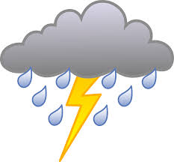

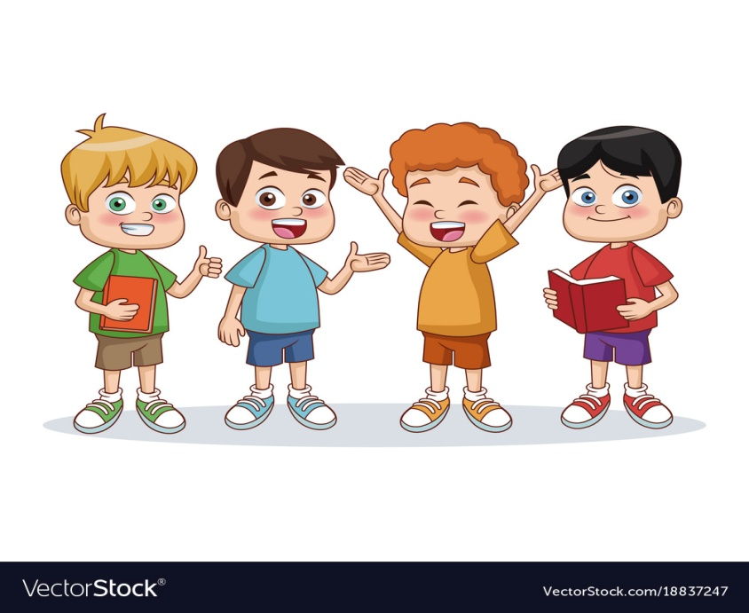

Ali Mehmet Hamza Muhammet

150cm 148 cm 151 cm 149 cm

50 kg 47 kg 52 kg 51 kg

18- Verilenler dikkate alındığında aşağıdakilerden hangisi **yanlıştır?**

1. Ali is taller than Mehmet.
2. Muhammet is fatter than Mehmet.
3. Ali is thinner than Hamza
4. Hamza is shorter than Muhammet

19- Zehra: It is breakfast time, come here, honey?

Meryem: OK, mom!...........................................

Zehra: Bagels, butter, eggs, cheese, olives and tomatoes.

Karşılıklı konuşmada boş bırakılan yere gelebilecek en uygun ifade aşağıda verilenlerden hangisidir?

1. Enjoy it!
2. Can I have some coffee.
3. I don’t like junk food.
4. What do we have for breakfast?

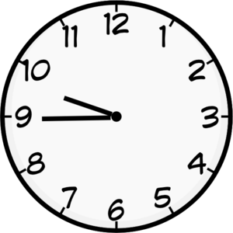

20-

1. It is nine o’clock
2. It is a quarter to ten o’clock
3. It is ten to ten o’clock
4. It is a quarter past ten o’clock